YRT3: Grow light Instructions  YRT3 – Escaped Alone | Abstract  This is an instruction to install, and strike grow light rack for YRT3 – Escaped Alone.  Surach, Leo  Props Manager

Table of Contents
1. Ground Plan 4
1.1 Symbol’s Description 5
2. Instruction for Setting Up the Grow light. 7
2.1 Step by Step 7
3. Instructions for Strike the Grow Light. 14
3.1 GP for Storage 14
3.2 Step by Step 15
4. Q&A 18
4.1 Why do the racks not turn on? 18
4.2 Why do the spider tripods not turn on? 18
4.3 Why do all the legs of the tripod not turn on? 19
4.4 Is it matters if we switch the side that we plug in the daisy chain? 19
4.5 What should we do if we accidentally adjust the height of the rack? 19
4.6 What should we do when we see the plants look sad? 19
4.6 What should we do if we turn the timer to a different setting? 20
4.7 What should we do if we press some buttons in the timer by accident? 20
4.8 What should we do if we accidentally move the pots? 20
4.9 Is it okay if we see some pot or other props are not in the same location with the picture? 20
4.10 What should we do if the problems we facing with are not in this Q&A? 20
4.11 What should we do if we accidentally move little speakers in the stage? 21
4.12 What should we do if we accidentally mess up the RP? 21
5 Contact List 21
6 Photo References 23

Table of Figures
1 UP STAGE LEFT CORNER 18
2 UP STAGE LEFT CENTER 19
3 UP STAGE LEFT CENTER 20
4 DOWN STAGE RIGHT CORNER 21
5 DOWN STAGE LEFT CORNER 22
6 DOWN STAGE RIGHT CORNER 22
7 OVER ALL STAGE VIEW (FROM AUDIENCE) 23
8 SL 1ST POWER STRIP AND CABLES 24
9 2ND POWER STRIP AND CABLES 25
10 SR POWER STRIPS AND CABLES 26

Acknowledgement

YRT3 – Escaped Alone at Yale Repertory Theatre has live plants on stage as an essential part of the show. There are 53 pots of 60 plants including one 8’ height black olive tree on stage, it is our goal to keep it alive for the purpose of the show and in the awareness of using living things on stage. As coming into the tech /focus/performance periods, we would like to set the grow lights for all our plants from 10:00pm to 10:00am every day to provide them to appropriate environment.
In the case that some work-call could happened before or after our staff working hours. We are making this document as instruction for other departments to helping us set up and strike them as easiest as possible.
We realized that all the plants are not in the most suitable condition for them in Yale Repertory theatre regards of sunlight, temperature, humidity and else. There are possibilities that any plants would losing their leaves or being in poor condition as mentioned.

DGSD’s Prop Team

Ground Plan
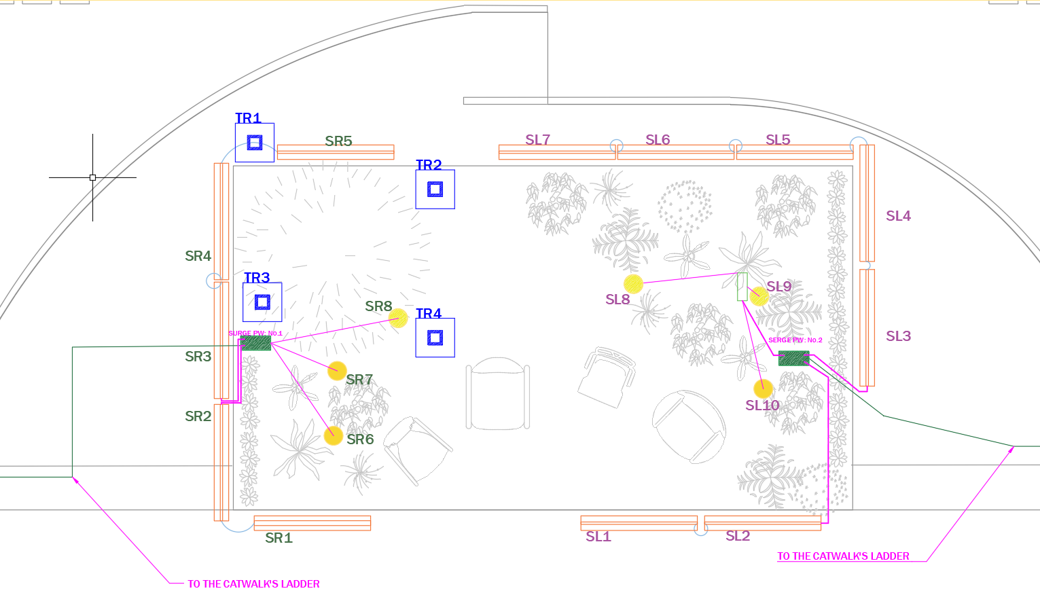
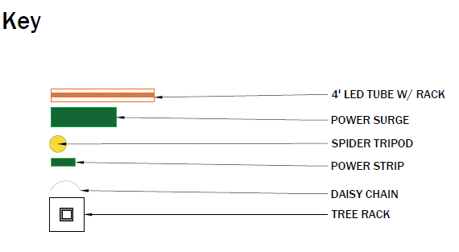

Symbol’s Description

- SR & SL means stage left and stage right.
  - There are tags on the top of the rack, which indicate the location of them based on GP.
  - 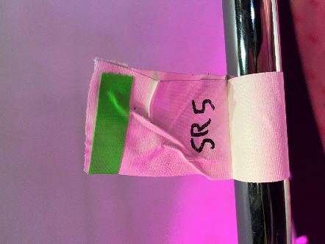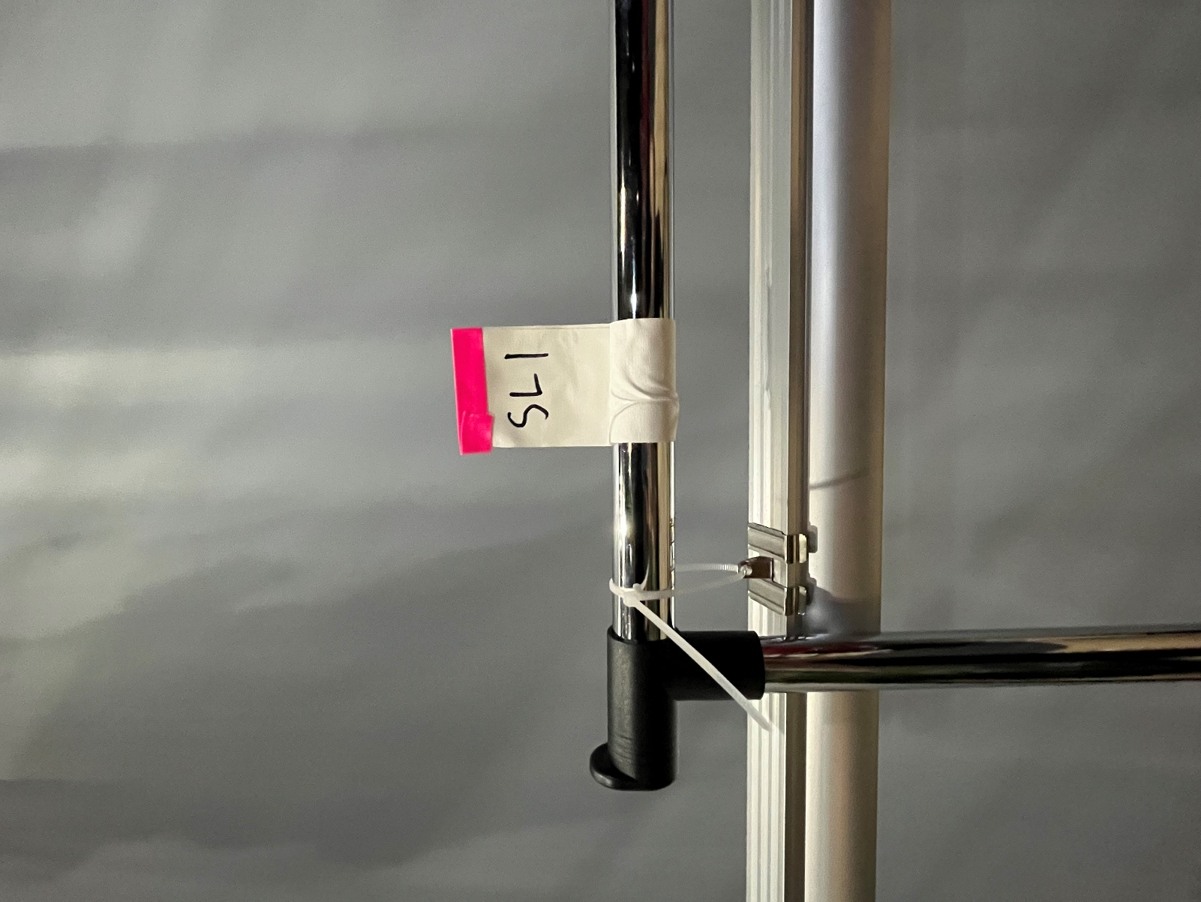
Green for SR & Pink for SL
- 4’ LED tube with Rack
  - 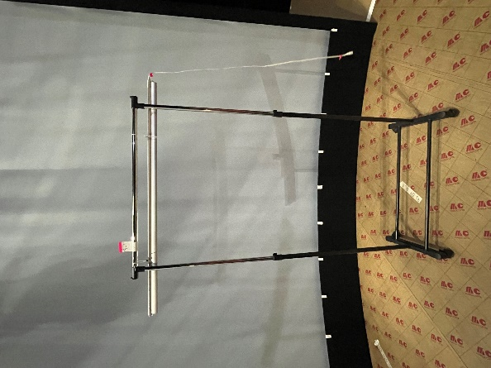
  - 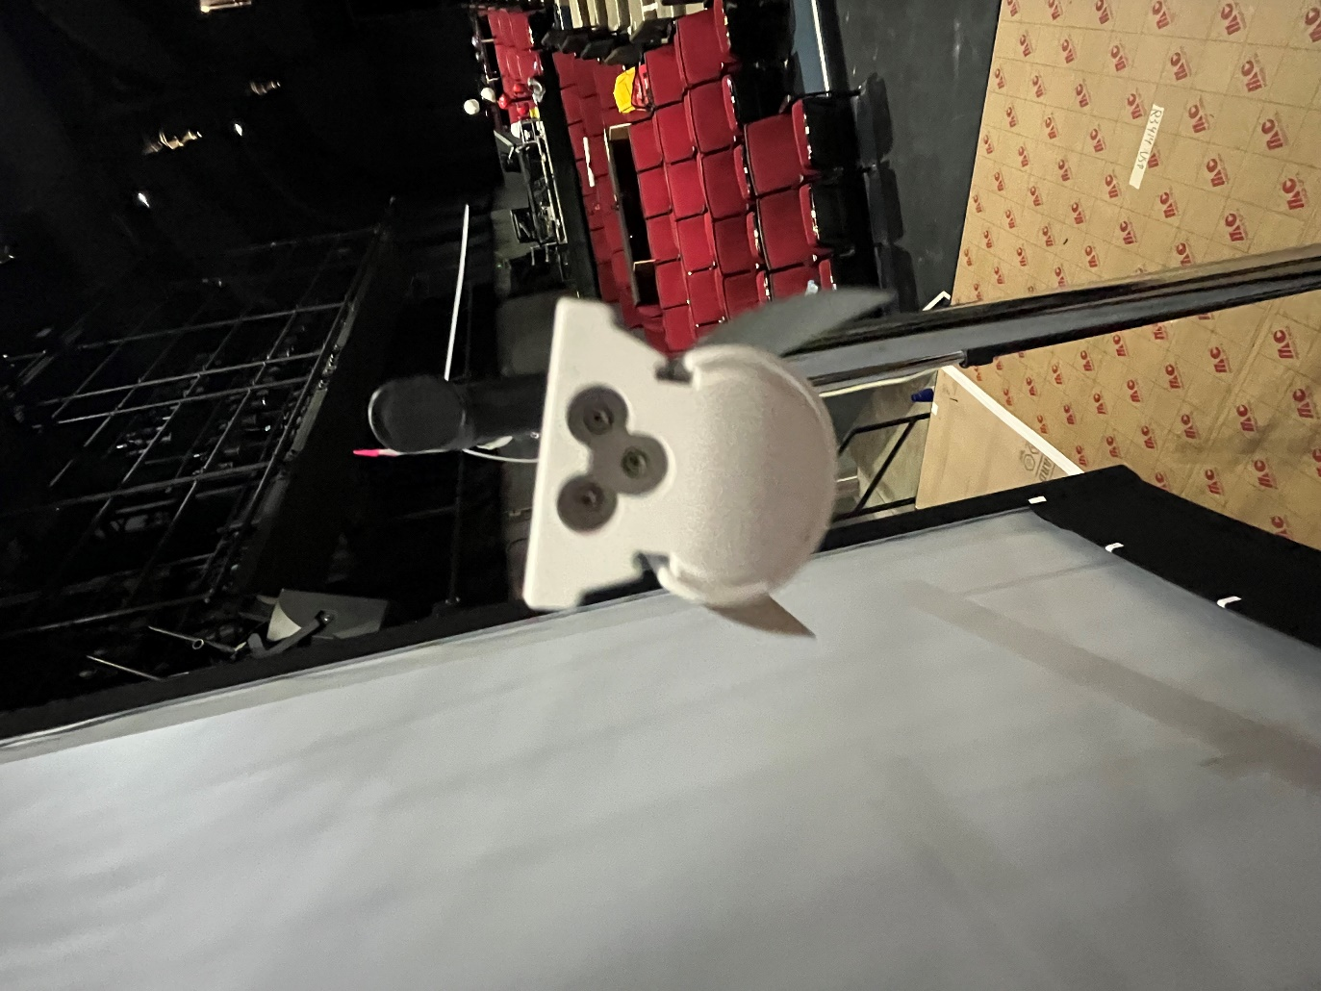
  - It’s two connections at both ends of the tube, we put the daisy chain and power line through these connections.
  - The daisy shows as blue line in the GP.

- Power Surge & Power Strips (the same now)
  - 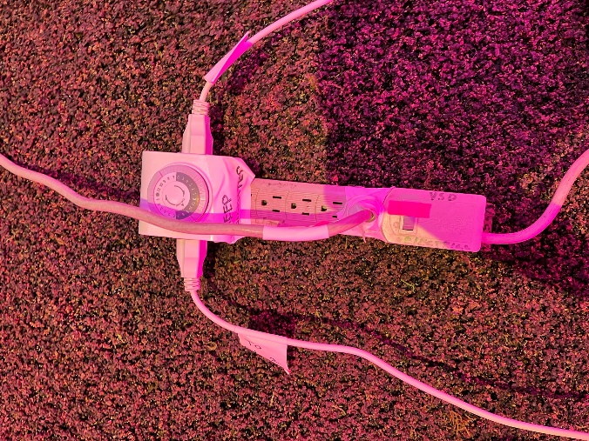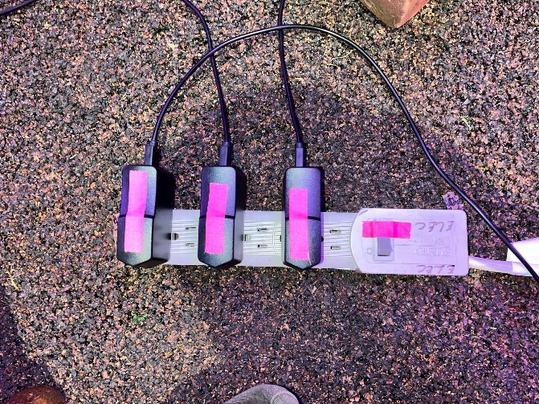
  - There is a timer plugged into the power strips, which will connect to our racks. The rest of the socket will leave for spider tripods.
- Spider Tripod
  - 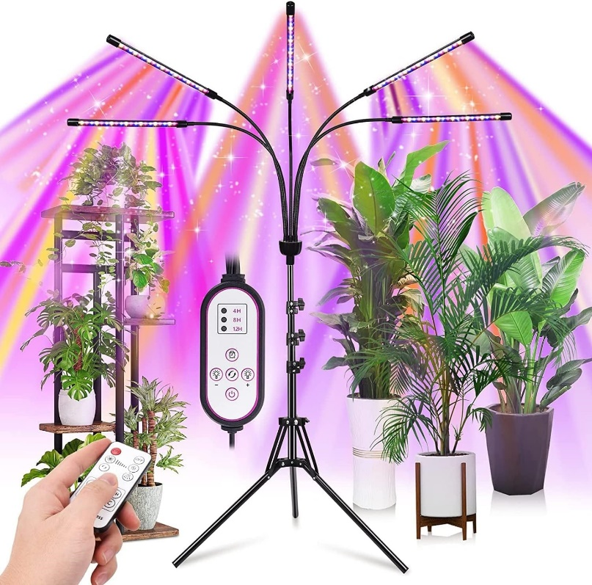
- Tree Rack
  - Will added soon.

Instruction for Setting Up the Grow light.

Step by Step
- Move all the grow light racks and tripods into their place as shown in the GP. (Please check Page 16 for more details.)
  - Sample Picture

    - 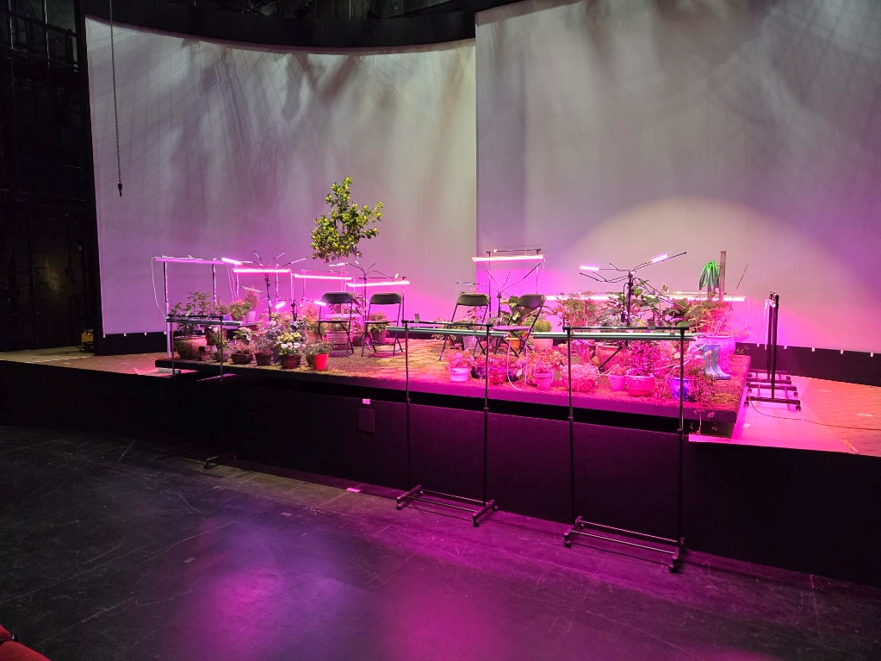
    - The rack should tuck under the stage.
    - There SR1, SL1 and SL2 stand on the audience ground level.
- Untie the power strips from both side of the stage, it’s tied with tie line to the ladder to the catwalk.
    - 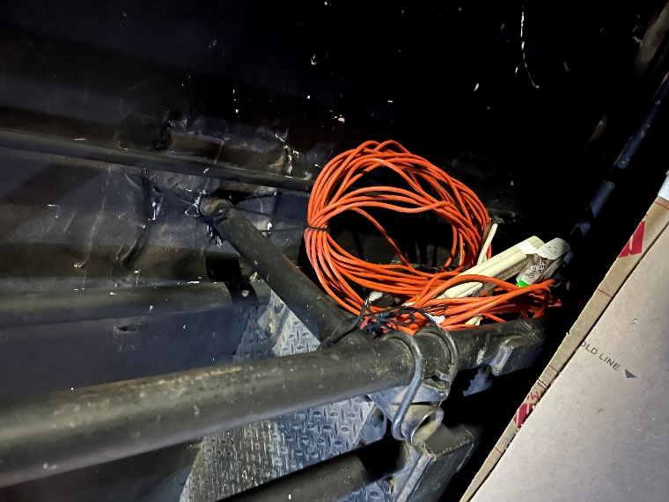
    - Untie only the one with the power strip.
- Move the power strip to the location as shown in the GP, also there are spike tape on the floor to indicate the location of it.
  - Sample picture
    - 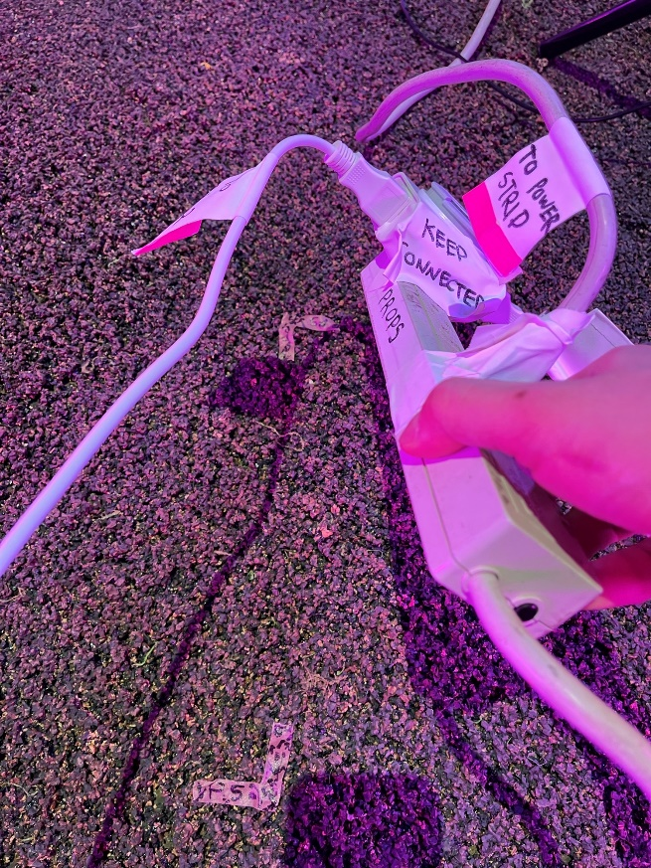
- Recheck the rack to make sure its facing the tube toward the stage
  - Sample picture
    - 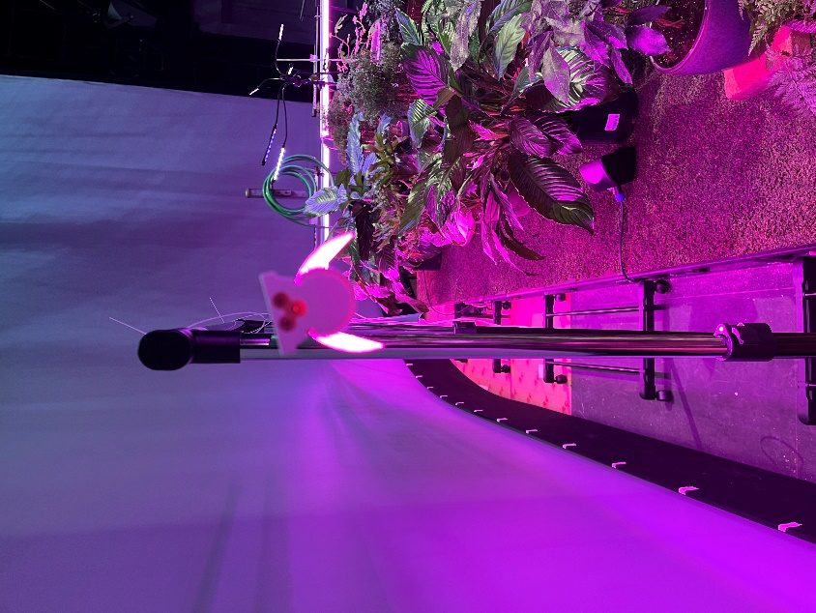
    - 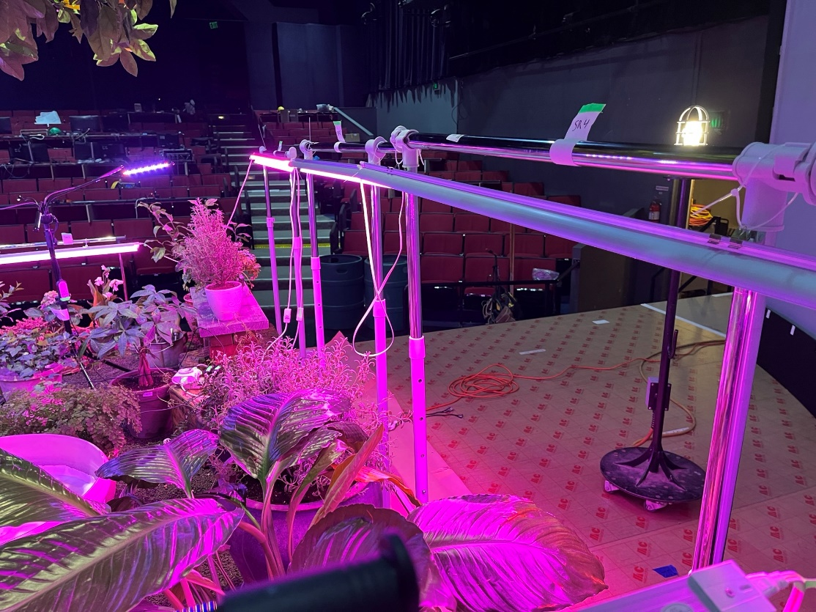
- Daisy chain the racks as shown in the GP (blue line)
  - Sample picture
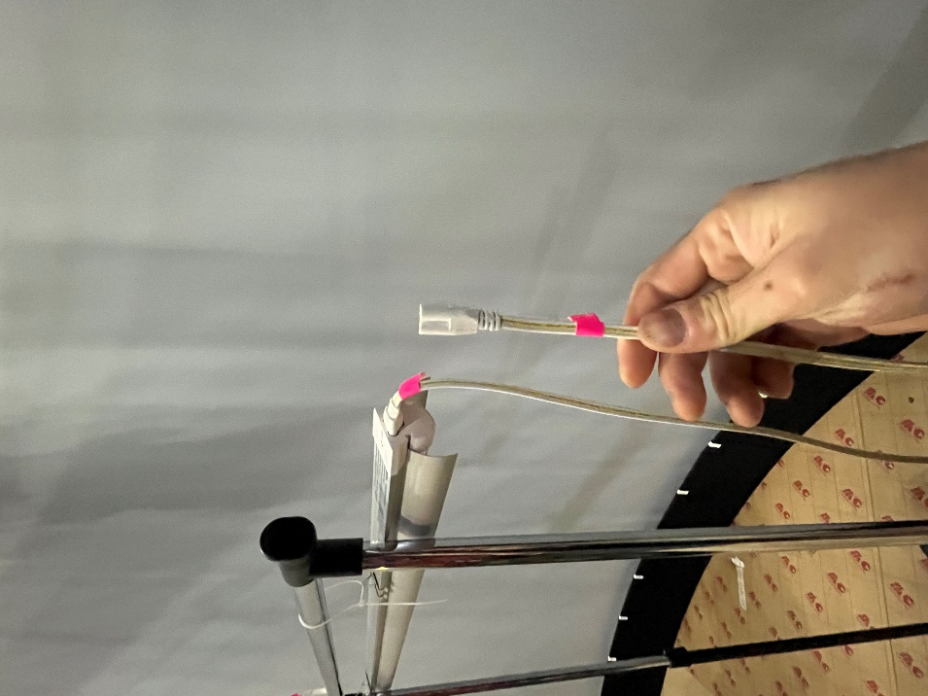

- Plug the racks power line to the power strips.
- Plug the tripod power line to the power strips.
  - Sample picture
    - SR power strip sample picture
      - 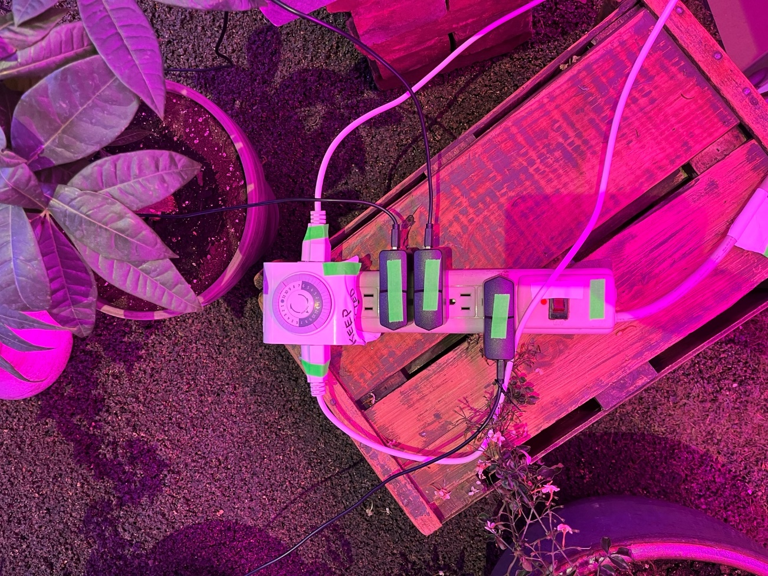
      - There are three black adaptor which from the spider tripods.
      - There is timer with two cables which from the racks

    - SL power strip sample picture
      - 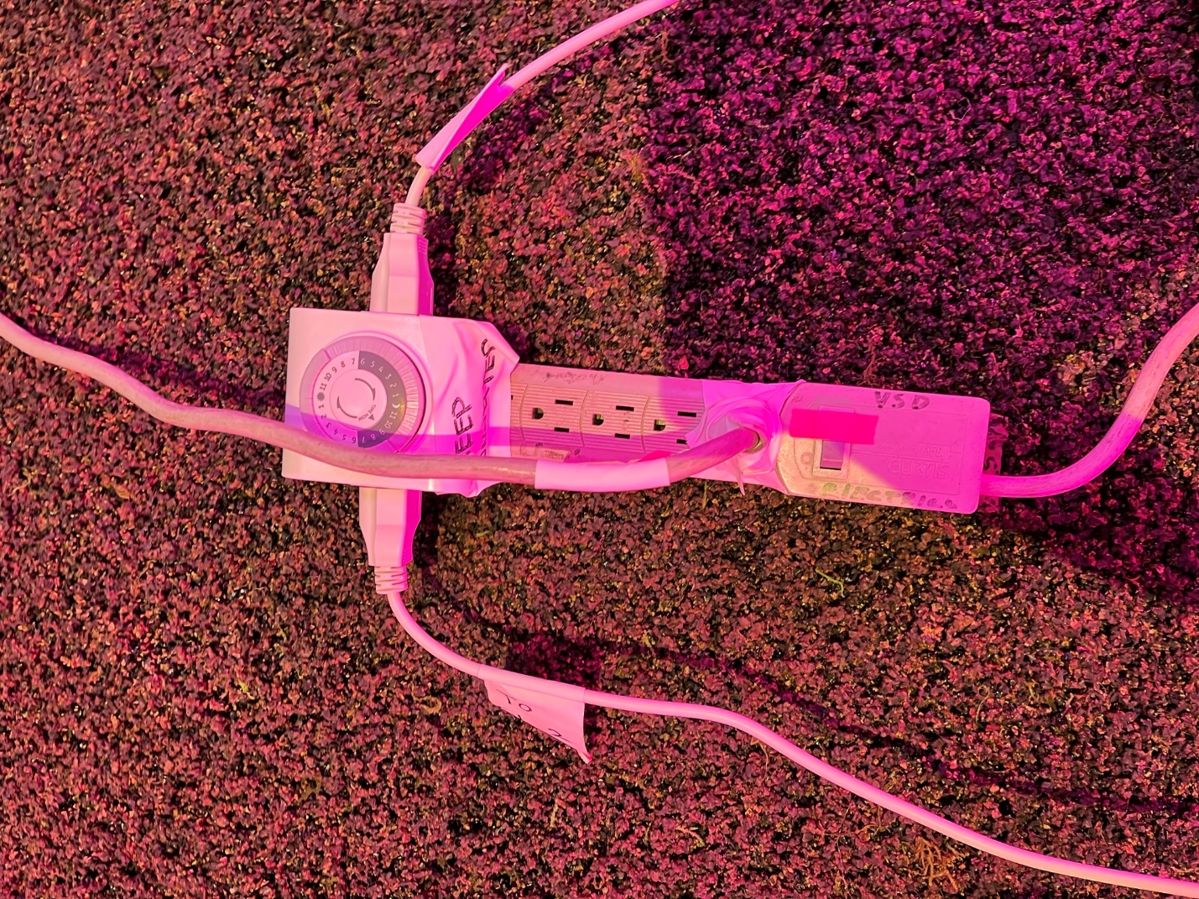
      - There is a timer with two cables from the racks and another one from another power strips.
      - SL 2nd power strips sample picture
      - 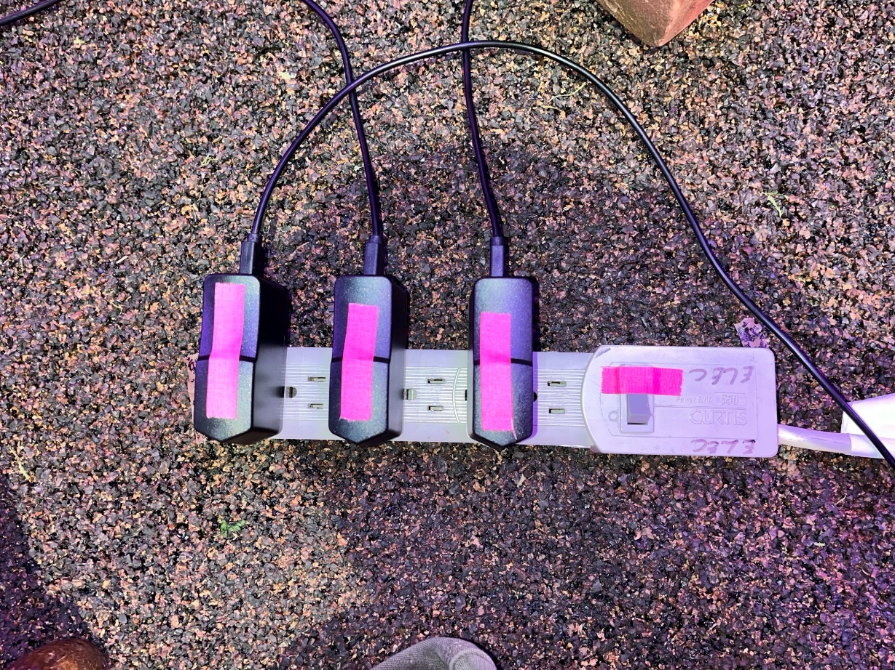
      - There are three black adaptors from three spider tripods.
- Adjust the height of the spider leg to cover most of the plants area.
  - There should be 1’-2’ higher than the plants (Do not go to close the plants!)
  - Sample picture
    - 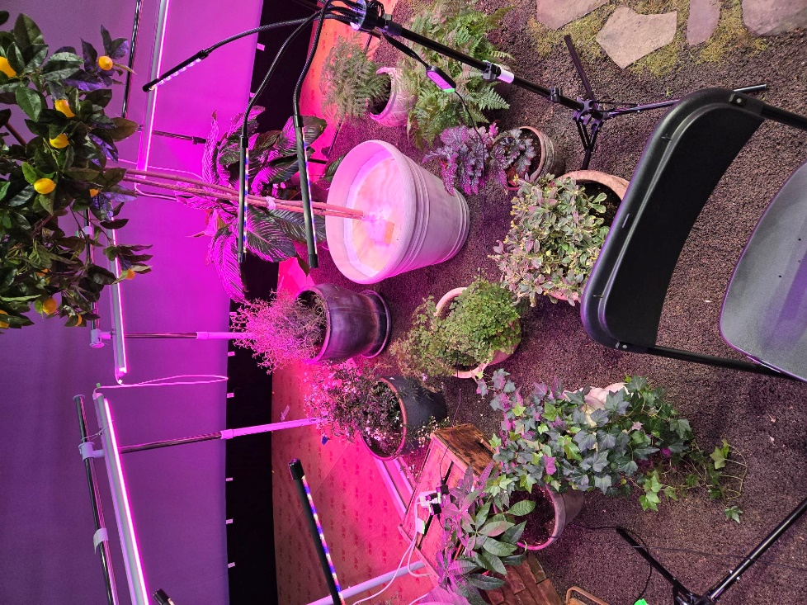
- Trouble shoot the system, if the lights do not turn on or else, please check Q&A section.

Instructions for Strike the Grow Light.

3.1 GP for Storage
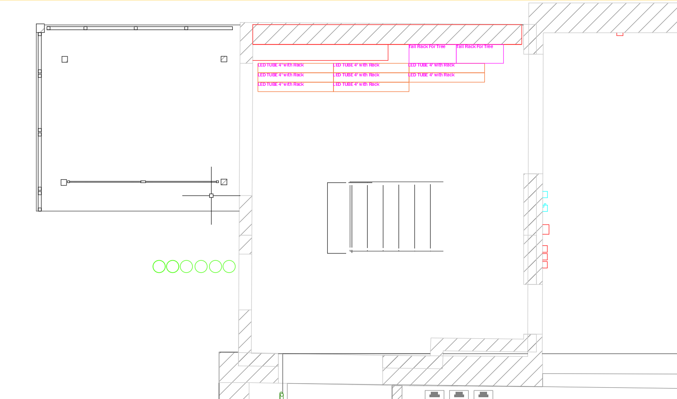

3.2 Step by Step
- Unplug all the cables from the power strip.
- Remove all the daisy chains from the racks.
- Wrapping the cable and keep it with the leg of the tripod.
Sample Picture

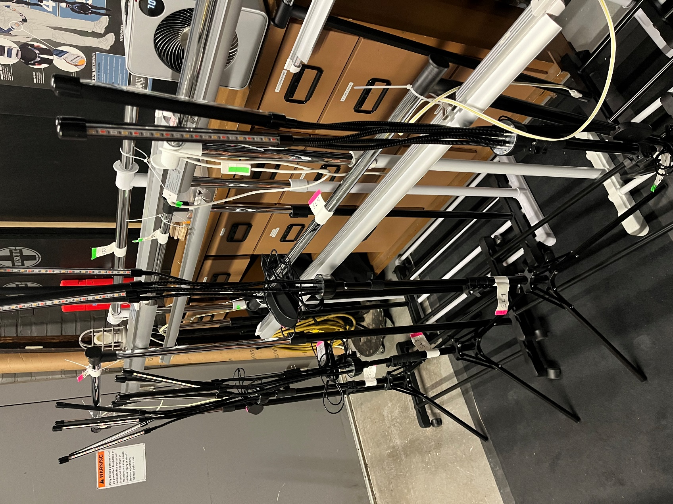

warp all the legs up to lock its cables.

- Wrap the power strips and tie them to the side of the stage.
Sample picture

- Move the racks in front of the rigging cabinet backstage as shown in the GP.
1st Sample picture
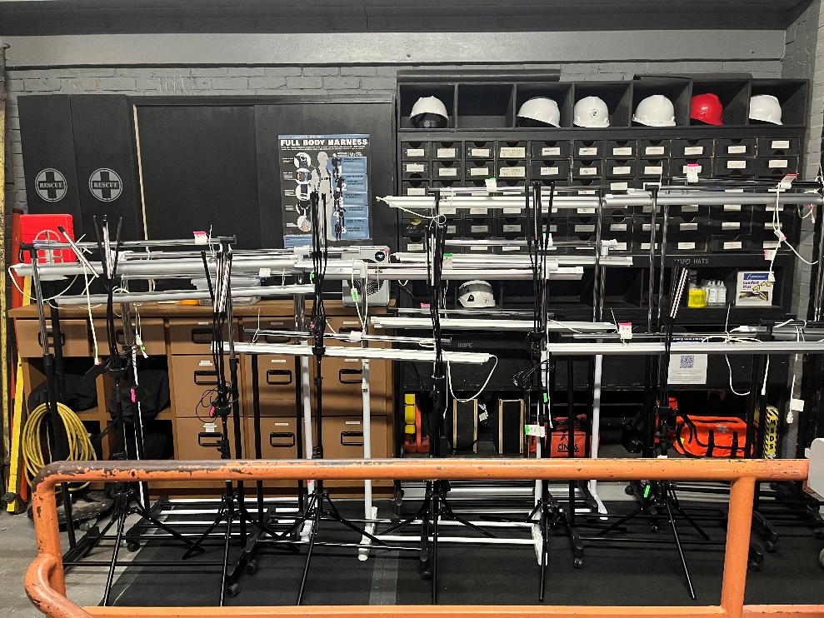
Reminder: the racks will be overlapped on each other in order to save some space.
2nd Sample picture
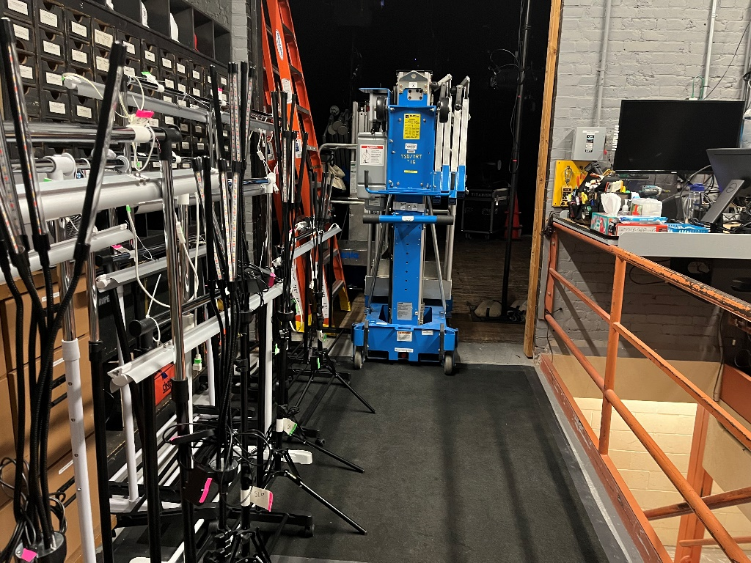
Reminder: Leave the room in front of the racks so the Genies can pass.

Q&A

4.1 Why do the racks not turn on?
A: There are two possibilities
1st, The loosening of the plug to the power strips.
2nd, It’s on the timers, so do not worry.

4.2 Why do the spider tripods not turn on?
A: There are two possibilities
1st, The loosening of the plug to the power strips.
2nd, The tripod need to restarts
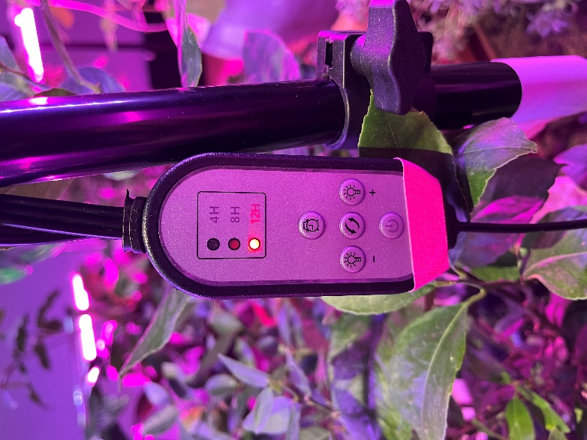
Please press the “power” button on the remote control, then press the “clock” button three times, so the light will turn on at the “12H”.

4.3 Why do all the legs of the tripod not turn on?
A:
Please press the “power” button on the remote control until it’s turned all the legs on. It’s required multiple command to turn on all the legs, one press will turn on one leg only.

4.4 Is it matters if we switch the side that we plug in the daisy chain?
A: No

4.5 What should we do if we accidentally adjust the height of the rack?
A: You can adjust it, please make sure that you make it 1’-2’ higher than the plants under that light.

4.6 What should we do when we see the plants look sad?
A: Report to Billy, Jen, or Leo either texts or email. Please do not water or anything. Some plants need a different treatment than others.
Billy : 203.676.2926 // william.ordynowicz@yale.edu
Jen :203.584.0412 // jennifer.mcclure@yale.edu
Leo: 203.627.3856 // leo.surach@yale.edu

4.6 What should we do if we turn the timer to a different setting?
A: 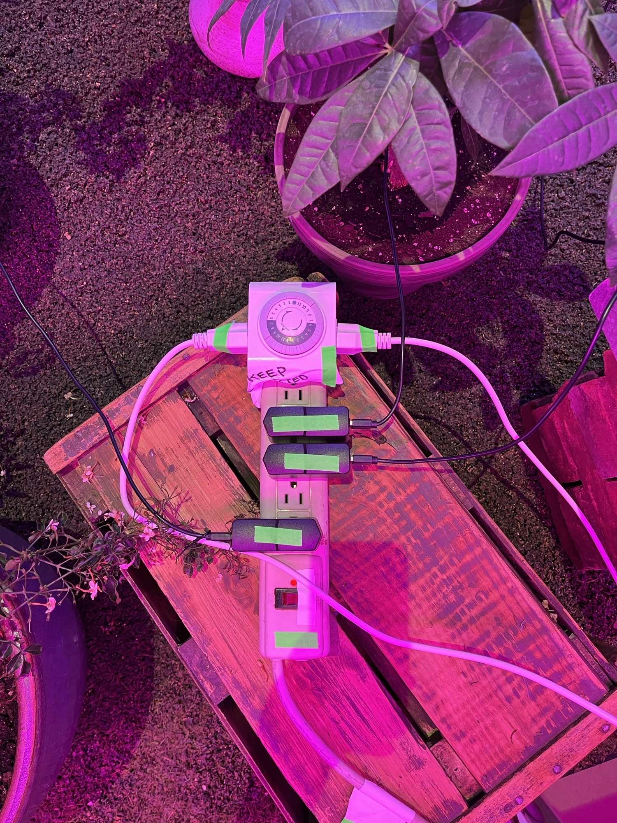
There is an arrow in the inner circle of the timer to indicate the present time. Please rotate the outer circle to match the number to the arrow. The number in the grey area indicates the nighttime, and the number in the white area indicates the daytimes.

4.7 What should we do if we press some buttons in the timer by accident?
A:
The button in the outside circle of the timer can be pressed and pulled. Which pressed mean “No Electricity” and pulled mean “Turn on Electricity”.
Please set the timer to turn on from 9p.m. to 9a.m.

4.8 What should we do if we accidentally move the pots?
A: contact Billy 203.676.2926 // william.ordynowicz@yale.edu
  - Is it okay if we see some pot or other props are not in the same location with the picture?
A: Totally Fine.

4.10 What should we do if the problems we facing with are not in this Q&A?
A: Please come to the props shop anytime or contact Leo, Jen, or Billy.
Billy : 203.676.2926 // william.ordynowicz@yale.edu
Jen :203.584.0412 // jennifer.mcclure@yale.edu
Leo: 203.627.3856 // leo.surach@yale.edu

4.11 What should we do if we accidentally move little speakers in the stage?
A: contact Shawn Poellet : 319.491.1645 // shawn.poellet@yale.edu

4.12 What should we do if we accidentally mess up the RP?
A: contact Keira Jacobs : 612.807.4670 // keira.jacobs@yale.edu

Contact List
Props Team
Billy Ordynowixz: 203.676.2926 // william.ordynowicz@yale.edu
Jen McClure :203.584.0412 // jennifer.mcclure@yale.edu
Leo Surach: 203.627.3856 // leo.surach@yale.edu
Technical Director
Keira Jacobs: 612.807.4670 // keira.jacobs@yale.edu
Sound engineer
Shawn Poellet: 319.491.1645 // shawn.poellet@yale.edu

Photo References
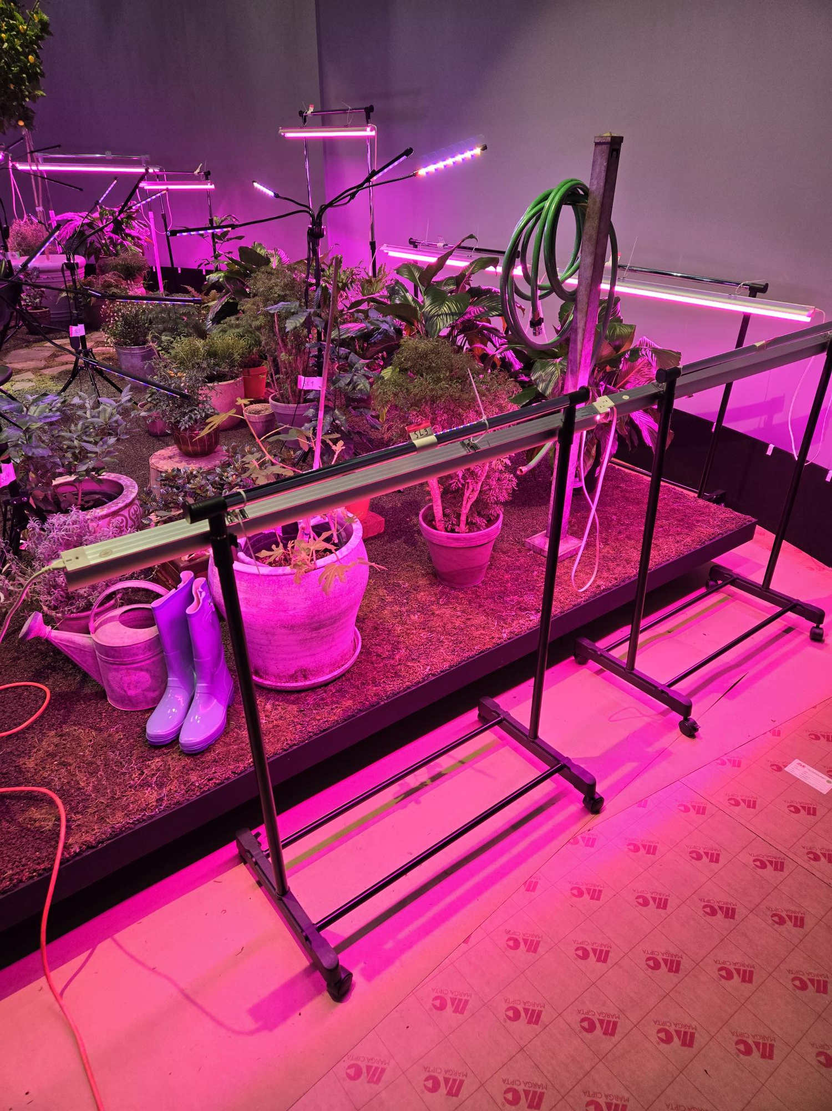
1 UP STAGE LEFT CORNER

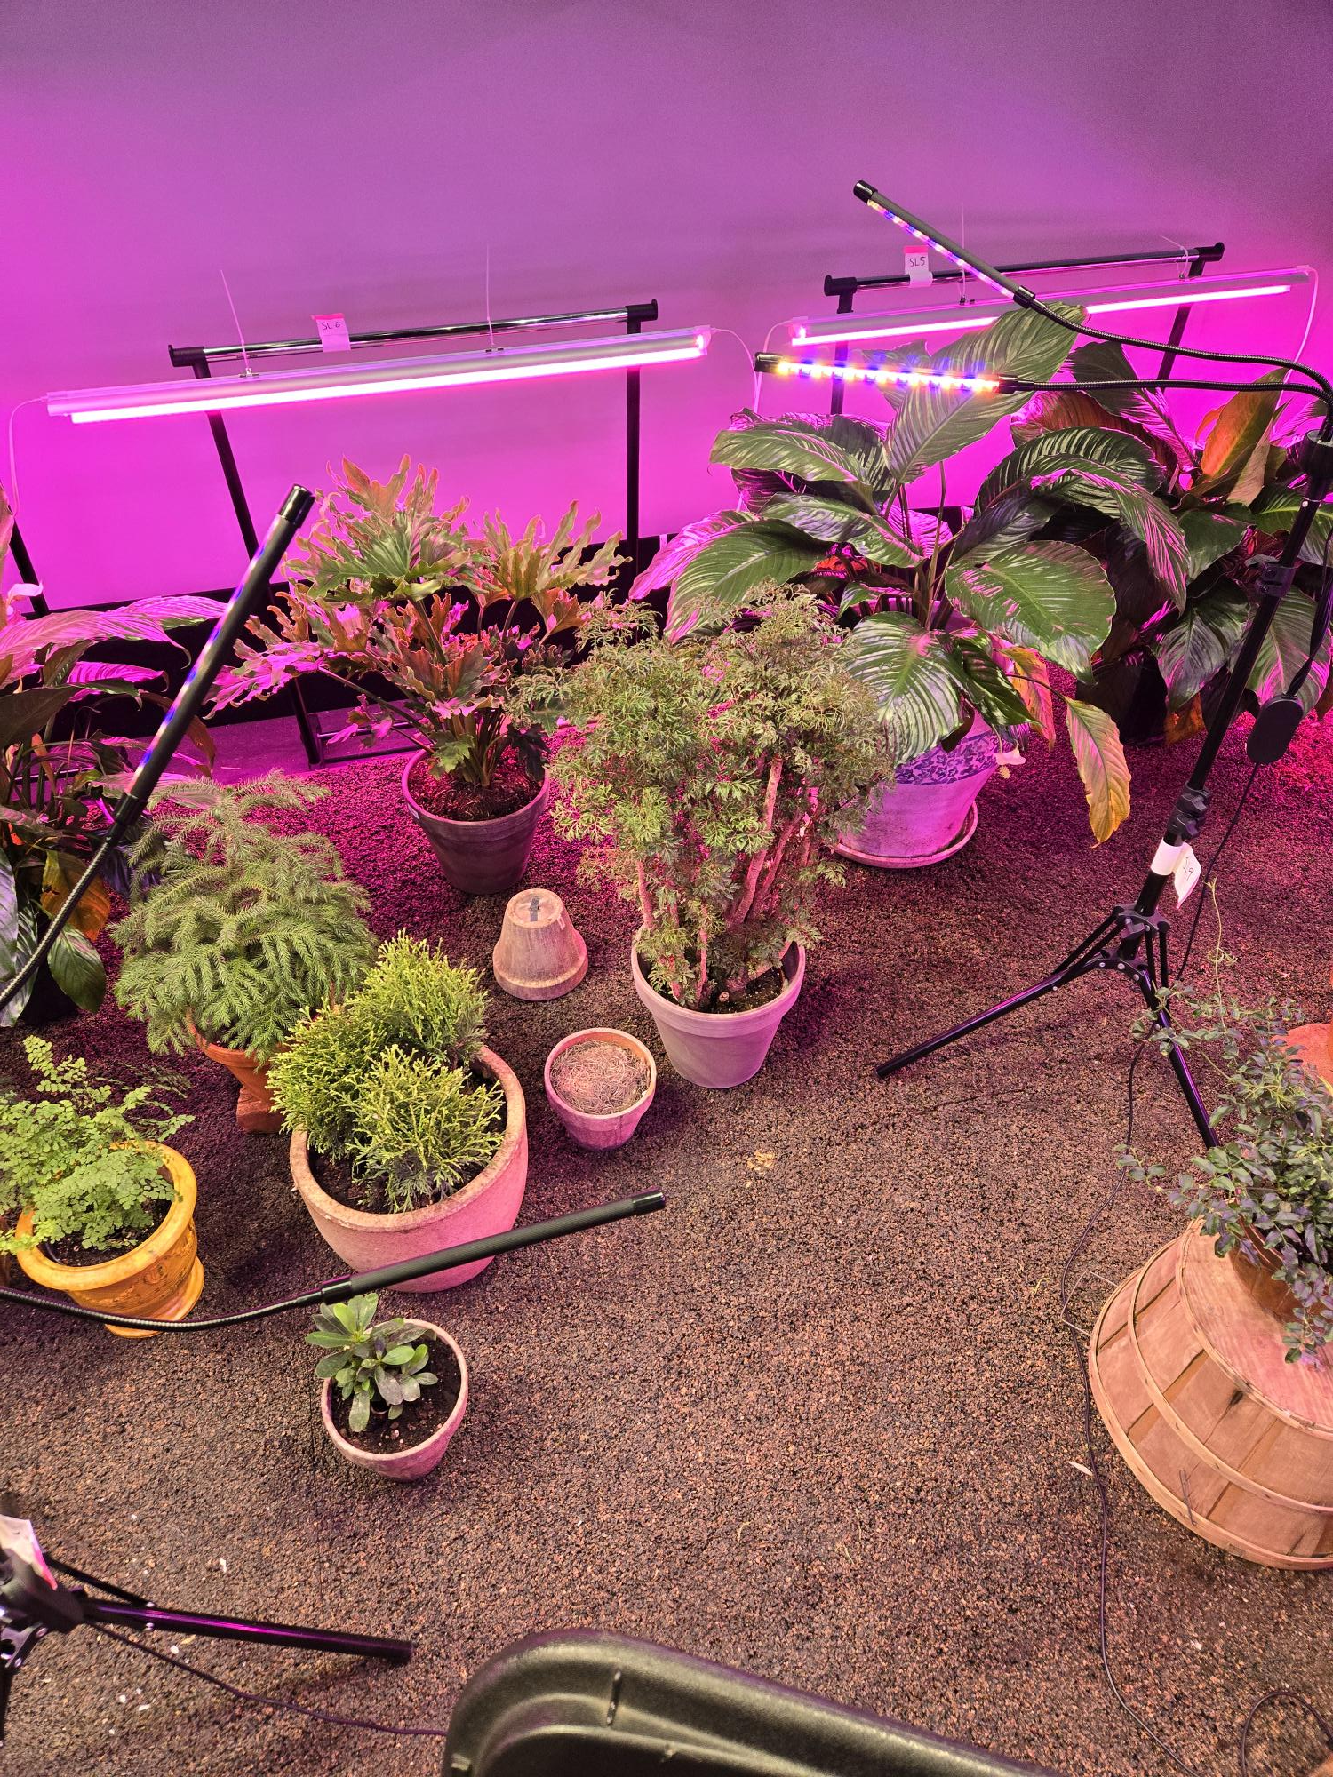
2 UP STAGE LEFT CENTER

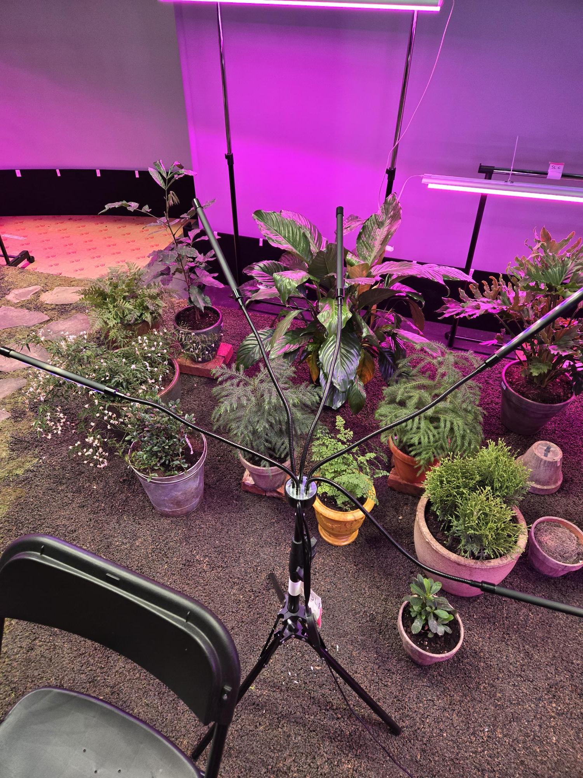
3UP STAGE LEFT CENTER
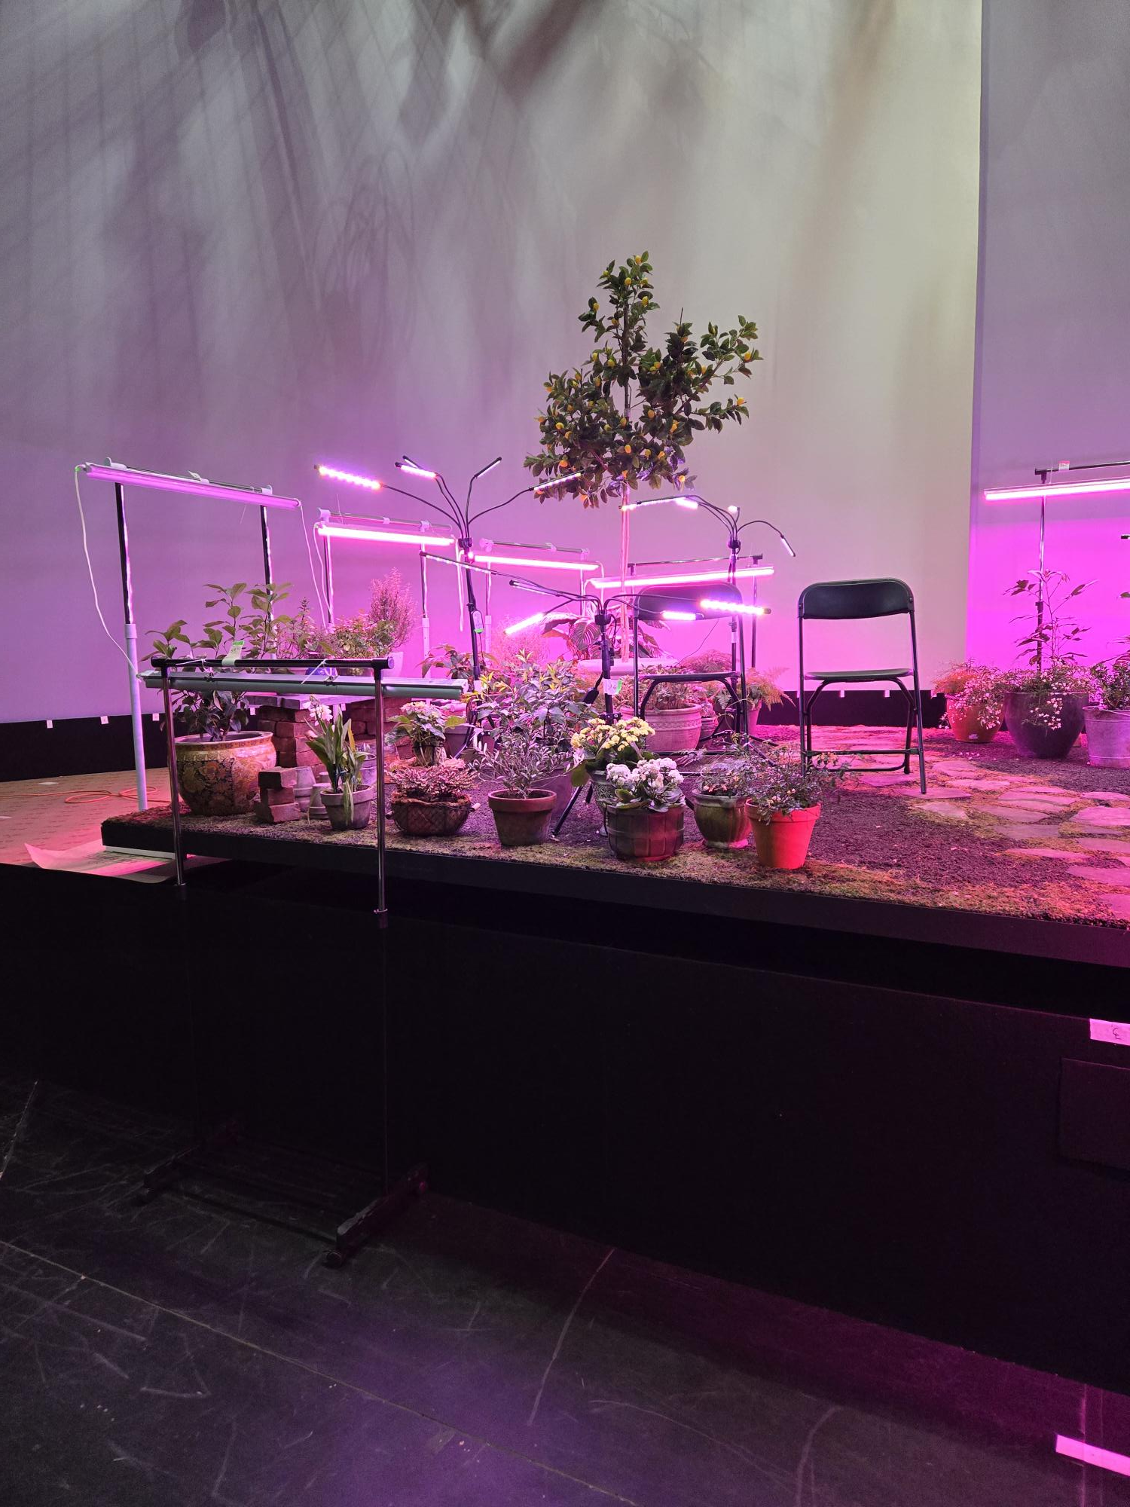
4DOWN STAGE RIGHT CORNER

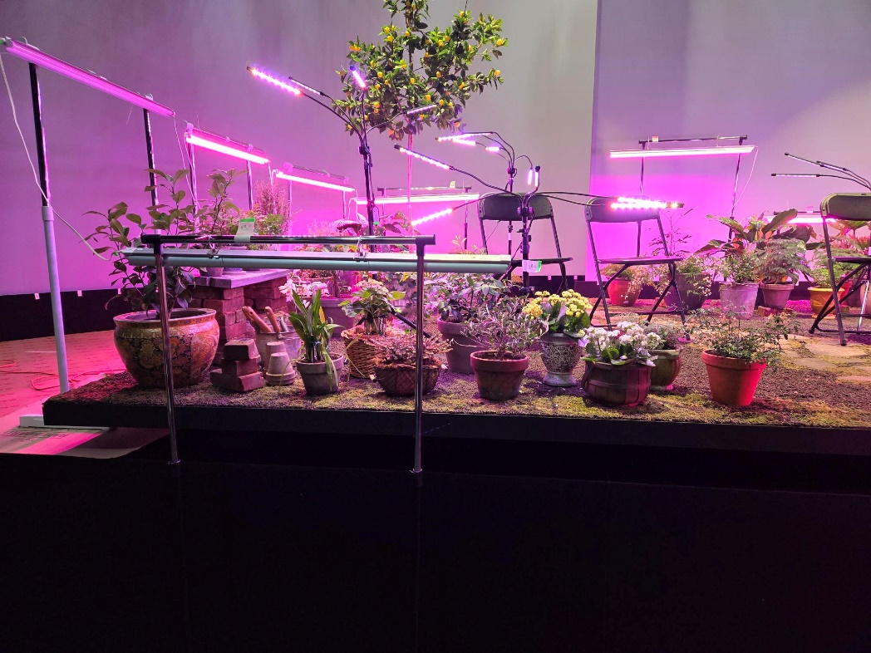
5DOWN STAGE LEFT CORNER
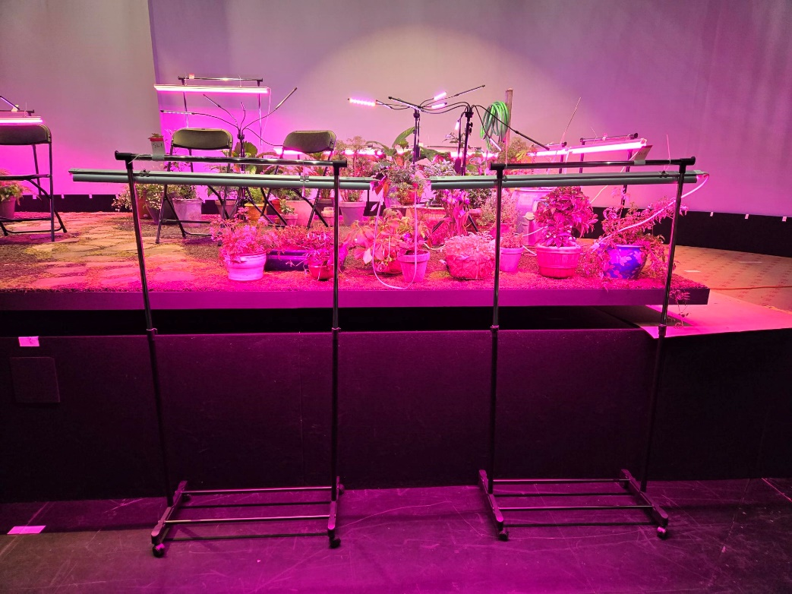
6DOWN STAGE RIGHT CORNER
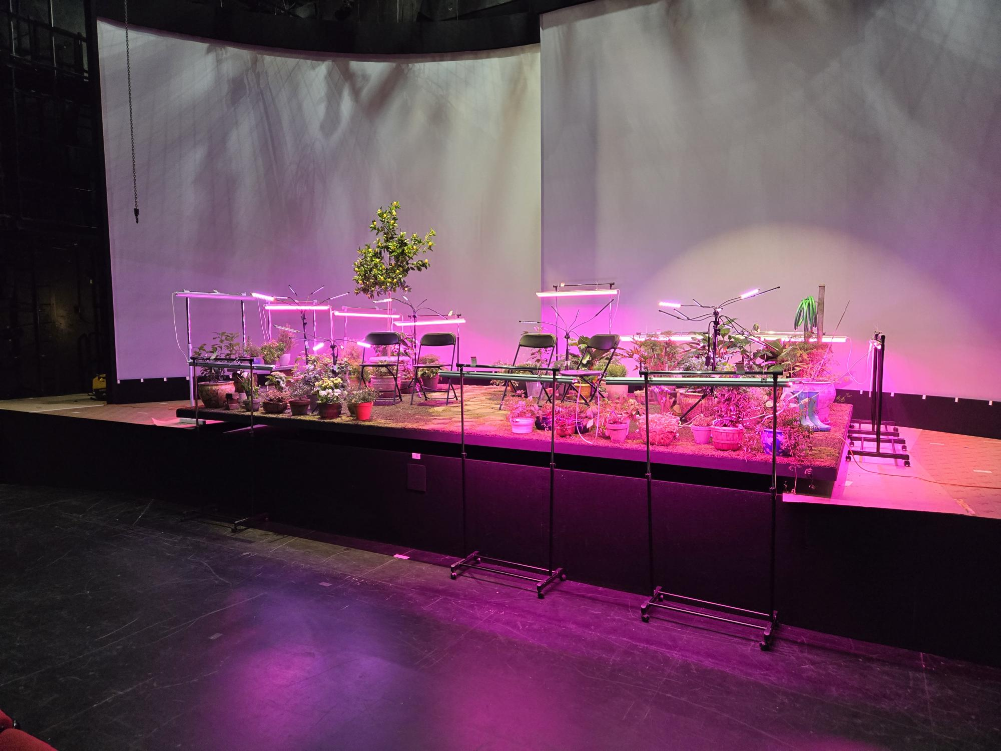
7 OVER ALL STAGE VIEW (FROM AUDIENCE)

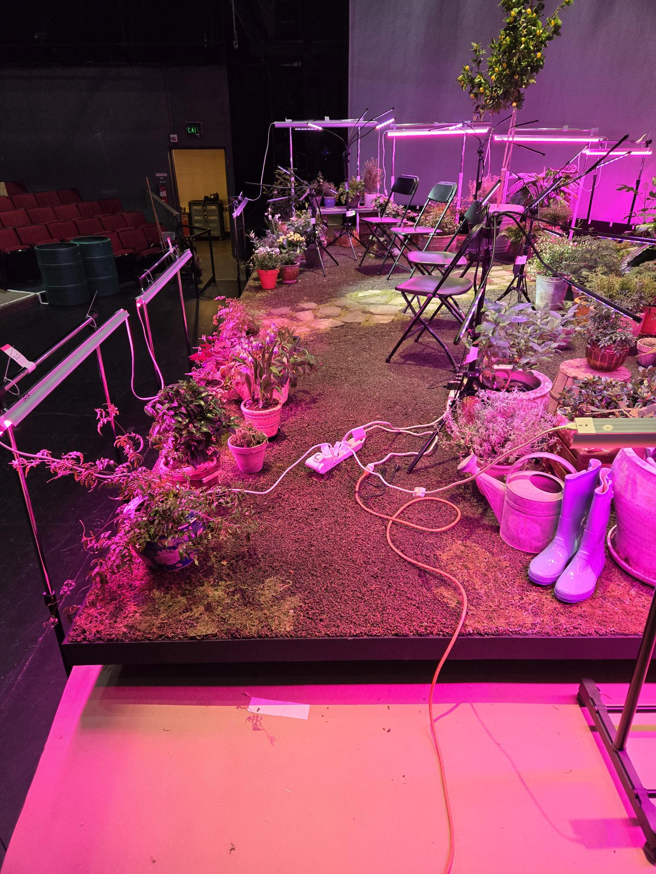
8 SL 1ST POWER STRIP AND CABLES

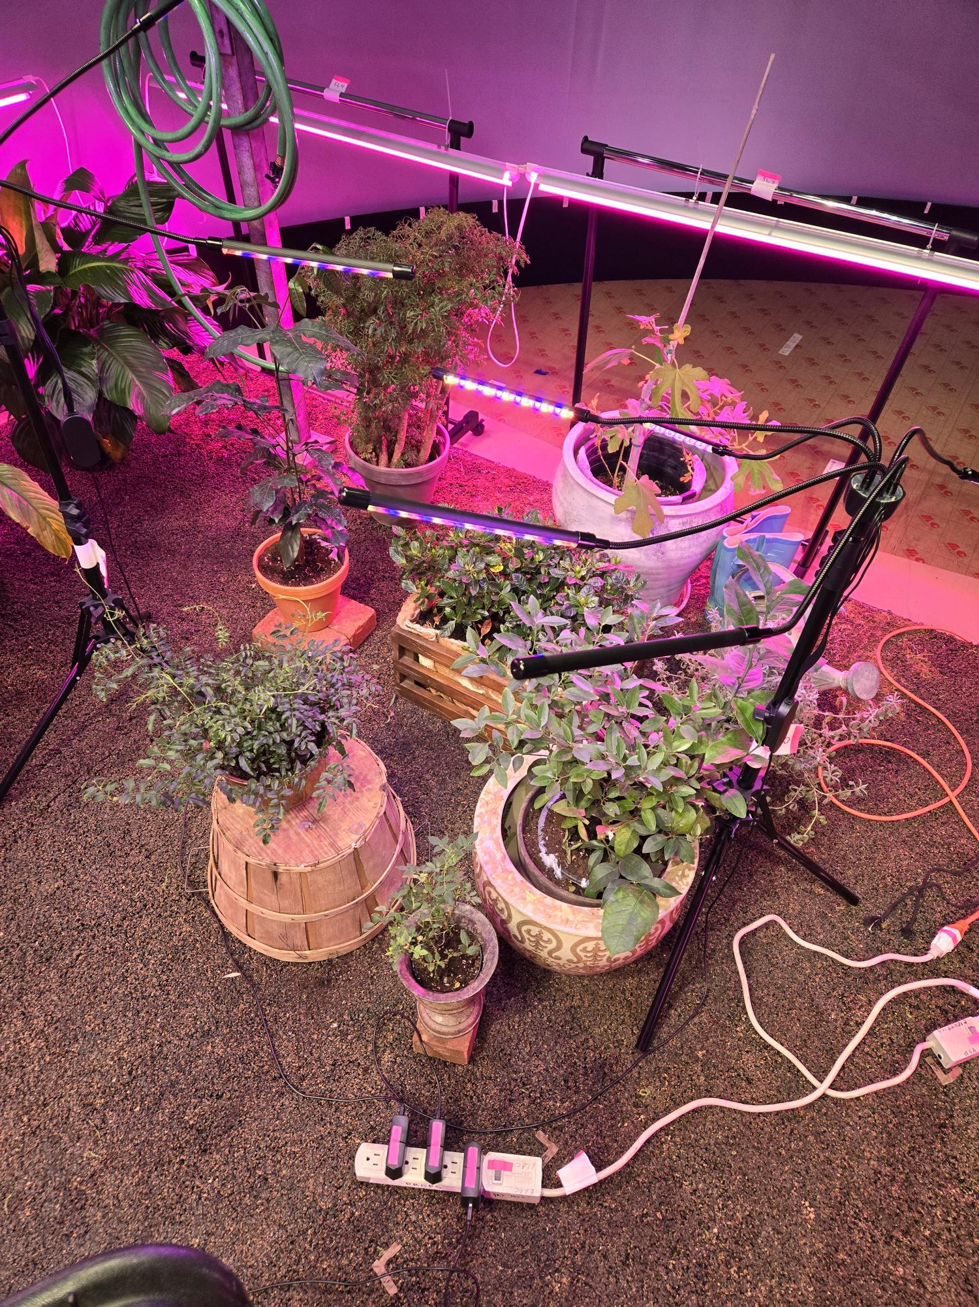
9 2ND POWER STRIP AND CABLES

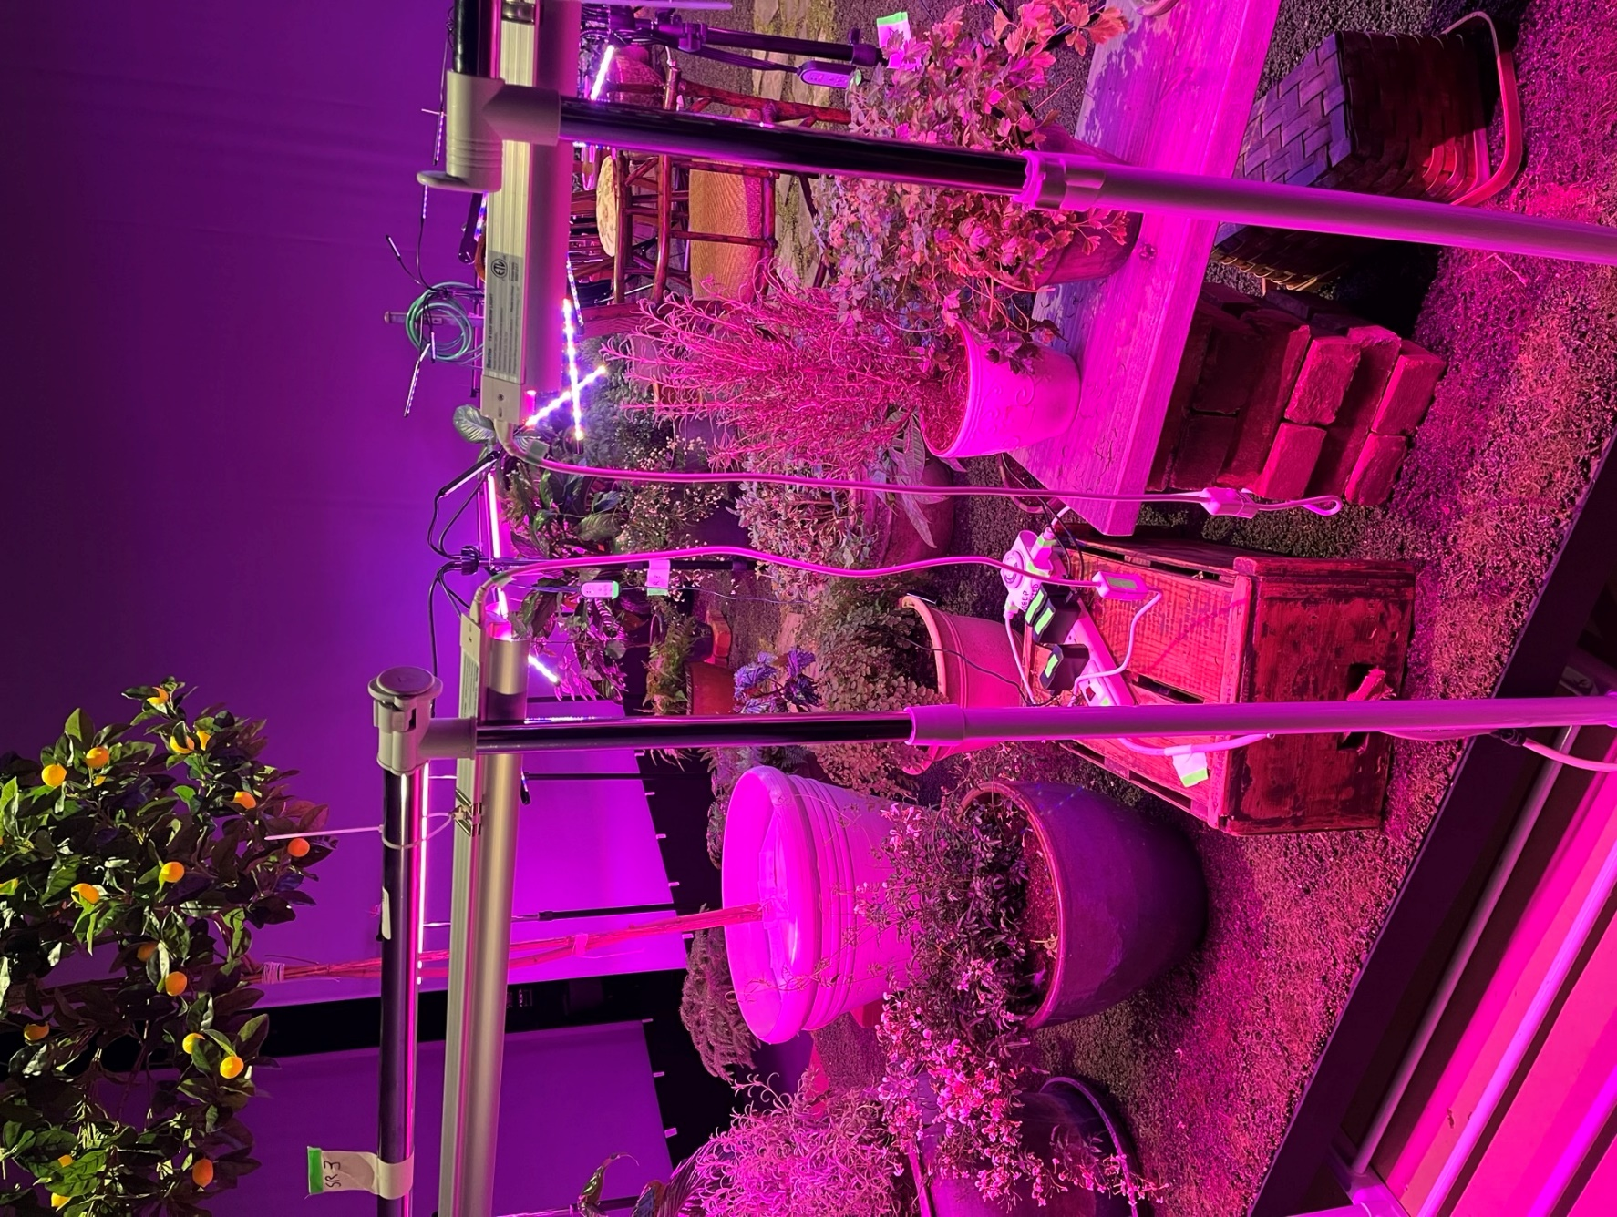
10 SR POWER STRIPS AND CABLES

